CO1_AT3 - Visualization Design Exercise

Question 1 – Retail Sales Visualization
Explanation:
- This visualization analyzes the performance of retail branches using multiple business variables.
- Sales and Profit are displayed on the X-axis and Y-axis to show their relationship.
- Bubble size represents the number of customers, while different colours identify product categories.
- Different shapes represent regions, making regional comparison easier.
- A logarithmic scale is applied to Sales to improve readability and compare both small and large values effectively.
Code:
library(ggplot2)

retail <- data.frame(
Branch=c("B1","B2","B3","B4","B5","B6","B7","B8","B9","B10",
"B11","B12","B13","B14","B15","B16","B17","B18","B19","B20"),
Region=c("North","South","East","West","North","South","East","West",
"North","South","East","West","North","South","East","West",
"North","South","East","West"),
Category=c("Electronics","Furniture","Clothing","Food","Electronics",
"Furniture","Clothing","Food","Electronics","Furniture",
"Clothing","Food","Electronics","Furniture","Clothing",
"Food","Electronics","Furniture","Clothing","Food"),
Sales=c(450000,620000,180000,920000,350000,720000,250000,1080000,
560000,670000,195000,980000,430000,760000,280000,1150000,
510000,690000,220000,1250000),
Profit=c(45000,95000,-12000,185000,25000,120000,18000,225000,
72000,98000,-8000,205000,51000,132000,24000,250000,
69000,115000,15000,285000),
Customers=c(1200,2500,980,4200,1800,3000,1250,5200,
2100,3300,1100,4700,1750,3600,1450,5600,
2200,3900,1600,6100)
)

# Bubble Chart
ggplot(retail,
aes(x = Sales,
y = Profit,
size = Customers,
color = Category,
shape = Region)) +

geom_point(alpha = 0.8) +

scale_x_log10() +

labs(
title = "Retail Sales Performance Across Branches",
x = "Sales (Log Scale)",
y = "Profit",
size = "Customers",
color = "Product Category",
shape = "Region"
) +

theme_minimal()

Output:
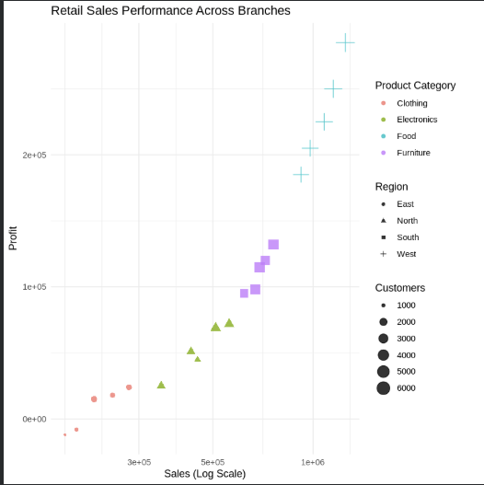

Question 2 – Electricity Generation Visualization
Explanation:
- This visualization compares monthly electricity generation from different energy sources.
- The Cartesian coordinate system uses a line chart to clearly show monthly trends.
- The Polar coordinate system displays the same data in a circular format to highlight seasonal patterns.
- Different colours distinguish Coal, Gas, Solar, Wind, and Hydro generation.
- The Cartesian coordinate system provides better analytical insight because it allows more accurate comparison of values over time.
Code:
library(ggplot2)
library(tidyr)

# Dataset
energy <- data.frame(
Month=month.abb,
Coal=c(620,580,590,605,640,670,690,720,700,680,650,630),
Gas=c(310,295,305,320,340,355,360,370,365,350,335,320),
Solar=c(45,60,90,130,180,230,250,245,210,160,90,50),
Wind=c(80,95,120,150,170,185,195,190,175,150,110,90),
Hydro=c(140,150,160,170,180,195,205,210,200,185,165,150)
)

# Convert into long format
energy_long <- pivot_longer(energy,
cols = -Month,
names_to = "Source",
values_to = "Generation")

# Cartesian Coordinate Plot
ggplot(energy_long,
aes(Month, Generation,
color = Source,
group = Source)) +
geom_line(size = 1.2) +
geom_point(size = 2) +
labs(title="Monthly Electricity Generation (Cartesian)") +
theme_minimal()

# Polar Coordinate Plot
ggplot(energy_long,
aes(Month, Generation,
fill = Source)) +
geom_bar(stat="identity") +
coord_polar() +
labs(title="Monthly Electricity Generation (Polar)") +
theme_minimal()

output:
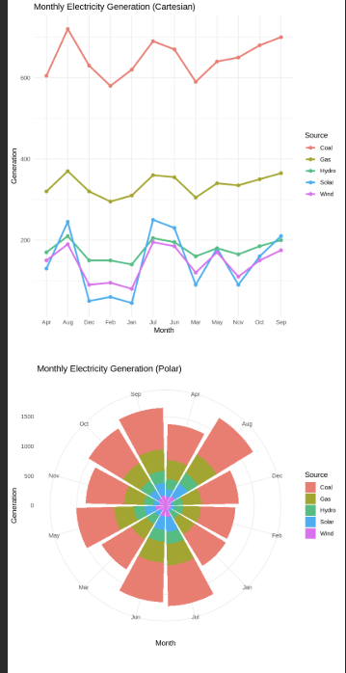
Question 3 – Climate Data Visualization
Explanation:
- This visualization represents climate conditions across major Indian cities.
- Temperature is plotted on the X-axis, while AQI is shown on the Y-axis.
- Bubble size indicates rainfall, and colour represents humidity levels.
- A blue colour gradient is used because it naturally represents moisture and humidity.
- The visualization helps compare temperature, rainfall, humidity, and air quality simultaneously.
Code:
library(ggplot2)

climate <- data.frame(
City=c("Delhi","Mumbai","Chennai","Kolkata","Hyderabad",
"Bangalore","Pune","Ahmedabad","Jaipur","Lucknow",
"Bhopal","Patna","Goa","Kochi","Nagpur","Indore",
"Surat","Visakhapatnam","Coimbatore","Mysuru"),

Temperature=c(44,35,38,40,39,31,33,43,45,39,
38,40,32,30,41,37,36,34,29,28),
Humidity=c(22,84,78,72,48,66,58,26,18,42,
36,45,89,91,30,34,76,82,68,64),
Rainfall=c(6,280,220,190,85,120,95,2,1,35,
48,72,360,410,12,20,180,240,130,145),
AQI=c(365,110,125,180,160,72,84,290,320,240,
175,220,58,52,270,190,145,98,60,55)
)

ggplot(climate,
aes(x=Temperature,
y=AQI,
size=Rainfall,
color=Humidity))+

geom_point(alpha=0.8)+

scale_color_gradient(low="lightblue",
high="darkblue")+

labs(title="Climate Data of Indian Cities",
x="Temperature (°C)",
y="AQI",
color="Humidity",
size="Rainfall")+

theme_minimal()

Output:
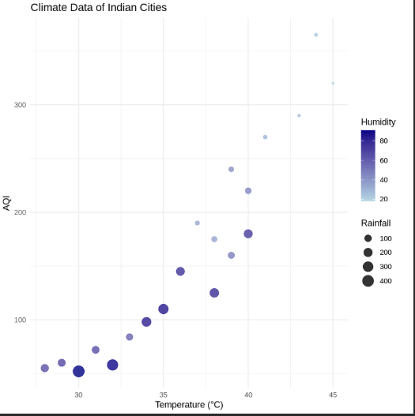

Question 4 – Software Project Visualization
Explanation:
- This visualization analyzes software project statistics using multiple project metrics.
- Lines of Code are plotted on the X-axis, while the number of bugs is shown on the Y-axis.
- Bubble size represents the number of developers, and colour indicates project complexity.
- A logarithmic transformation is applied because the Lines of Code values are highly skewed.
- The log scale improves readability by making both small and large projects easier to compare.
Code:
library(ggplot2)

software <- data.frame(
Team=paste("T",1:20,sep=""),
LinesOfCode=c(12000,18000,25000,35000,48000,
62000,81000,96000,120000,150000,
185000,240000,310000,390000,480000,
620000,810000,1050000,1350000,1800000),

Bugs=c(35,52,60,72,88,
110,125,142,165,188,
205,240,280,320,365,
420,490,560,640,720),

Developers=c(5,7,9,10,12,
14,16,18,20,22,
25,28,30,34,38,
42,46,50,55,60),

Complexity=c(2.1,2.4,2.7,3.0,3.2,
3.5,3.8,4.1,4.5,4.8,
5.1,5.4,5.8,6.2,6.6,
7.1,7.6,8.0,8.5,9.0)
)

ggplot(software,
aes(LinesOfCode,
Bugs,
size=Developers,
color=Complexity))+

geom_point(alpha=0.8)+

scale_x_log10()+

scale_color_gradient(low="green",
high="red")+

labs(title="Software Project Analysis",
x="Lines of Code (Log Scale)",
y="Number of Bugs")+

theme_minimal()

output:
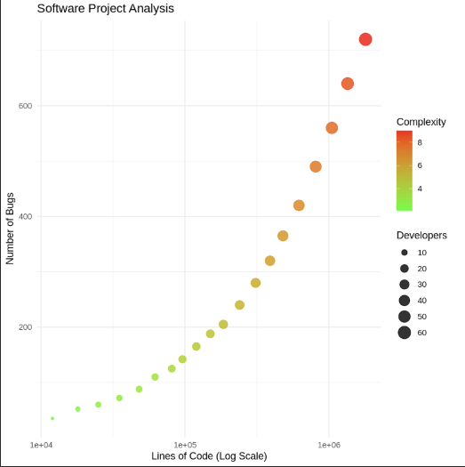
Question 5 – Financial Company Visualization
Explanation:
- This visualization compares the financial performance of publicly listed companies.
- Revenue is shown on the X-axis, while Profit Margin is displayed on the Y-axis.
- Bubble size represents Market Capitalization, and different colours indicate Industry Sectors.
- The scatter plot makes it easy to compare company performance across multiple variables.
- This integrated visualization effectively presents revenue, profitability, market value, and sector information in a single chart.
Code:
library(ggplot2)

companies <- data.frame(
Company=paste("C",1:20,sep=""),
Sector=c("IT","Banking","Healthcare","Retail","Energy",
"IT","Banking","Healthcare","Retail","Energy",
"IT","Banking","Healthcare","Retail","Energy",
"IT","Banking","Healthcare","Retail","Energy"),

Revenue=c(420,580,720,850,980,
1150,1320,1480,1650,1820,
2050,2280,2550,2840,3150,
3480,3860,4250,4680,5200),

ProfitMargin=c(8.2,15.6,11.4,9.3,18.5,
20.4,17.8,14.2,10.5,22.1,
24.5,19.8,16.7,13.4,26.2,
28.1,21.5,18.3,15.2,30.4),

Employees=c(1500,3200,2100,4200,2800,
5100,6800,3900,7200,4500,
8100,9500,6200,10300,7200,
11800,13200,8600,14500,16000),

MarketCap=c(8500,12000,9800,7600,14500,
18200,21500,16800,13200,24500,
28500,32500,24800,19200,38200,
42500,46800,35600,29800,52000)
)

ggplot(companies,
aes(x=Revenue,
y=ProfitMargin,
size=MarketCap,
color=Sector))+

geom_point(alpha=0.8)+

scale_size_continuous(range=c(3,12))+

labs(title="Company Performance Analysis",
x="Revenue",
y="Profit Margin (%)",
size="Market Capitalization",
color="Industry Sector")+

theme_minimal()

Output:
